Telescopic valve

Telescopic valve for controlling the water level or drawing off turbid water in an open basin with the following design features:

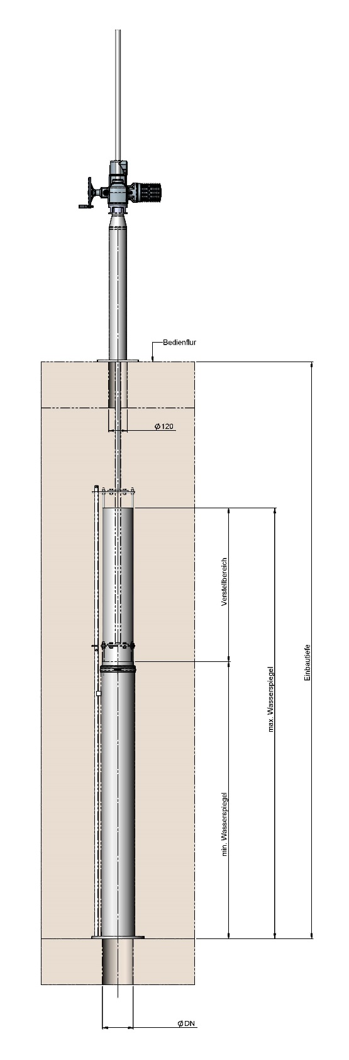
Opening size DN 100 to DN 600

- Seal between the standpipe and adjustable pipe is replaceable
- Flange joint seal included
- Seal material: EPDM / NBR
(Delete as applicable)

A valid welding certificate of at least execution class EXC3 according to DIN EN 1090-2, from the manufacturer must be attached to the offer.

Material: SS304 / SS316L (delete as applicable)

Tightness class
- Leakage rate to EN 19569, Part 4, Table 1:
  - Max. 10 % from 0.05 to 0.1 l/s/m (tightness class 3)

Telescopic valve mounting options
- Connection to on-site flange with hole pattern PN10
Optional: Other hole pattern possible
- Dowelled into the bottom of the basin

Telescopic valve designed for:
Nominal size DN: __________________ mm

Adjustable range: __________________ mm

Height of standpipe: __________________ mm

Installation depth: __________________ mm

Total height: __________________ mm
(distance between flange joint and max. water level)

Telescopic valve actuated by:
- Handwheel
Optional: Stainless steel handwheel
- E-actuator on headstock
- Pneumatic cylinder
- In an open basin: Bracket headstock
(Delete as applicable)

Optional:
- Leaf trap on inlet side

BÜSCH telescopic valve or equivalent

Manufacturer: BÜSCH Armaturen Geyer GmbH
Industriestraße 1
09468 Geyer
Germany
www.buesch.com

Quantity ........... EURO/each............ EURO/item ...........

